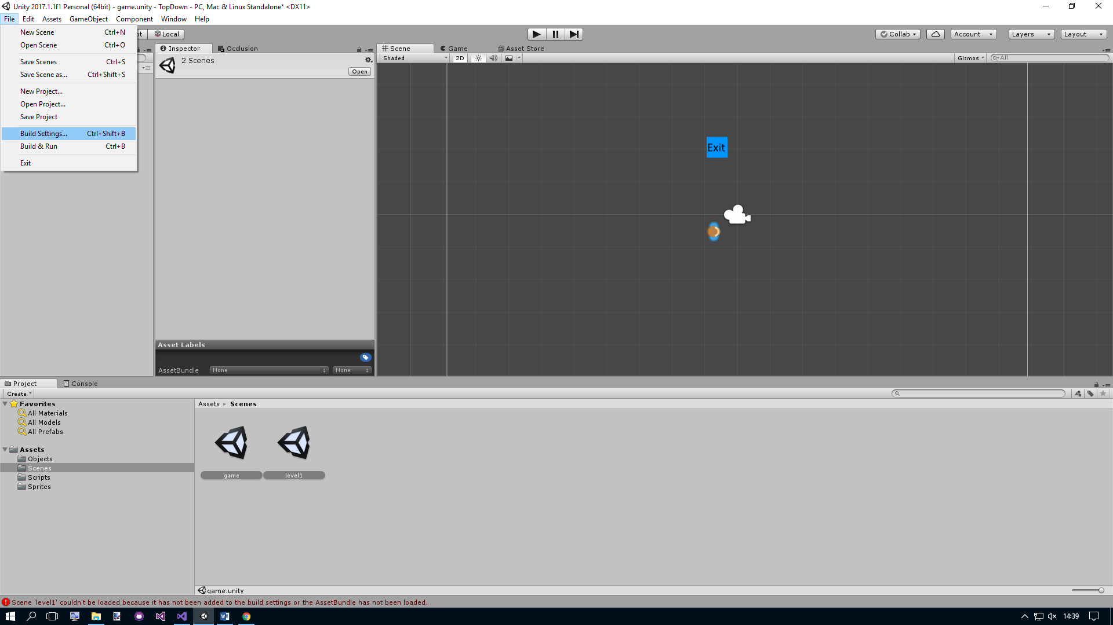

* Drag all scene that you require in the final game into the Scenes in Build Box (shown below)

